PRECISION AGRICULTURE USING MACHINE LEARNING & IOT

|  |  |  |
| --- | --- | --- |
| Prof. Rachna Sable  Department. of Comp & IT  G. H. Raisoni Institute of Engineering & Technology  *(Savitribai Phule Pune University)*  Pune, India | Prof.Vaishali Bhaviskar  Department. of Information Technology  G. H. Raisoni Institute of Engineering & Technology  *(Savitribai Phule Pune University)*  Pune, India | Atharva Labhasetwar  Department. of Information Technology  G. H. Raisoni Institute of Engineering & Technology  *(Savitribai Phule Pune University)*  Pune, India |

|  |  |
| --- | --- |
| Venkata Narayana B  Department. of Information Technology  G. H. Raisoni Institute of Engineering & Technology  *(Savitribai Phule Pune University)*  Pune, India | Kundan Patil  Department. of Information Technology  G. H. Raisoni Institute of Engineering & Technology  *(Savitribai Phule Pune University)*  Pune, India |

**Abstract**: **Agriculture is a major source of income and employment in India. The most prevalent problem faced by Indian farmers is that they do not select the appropriate crop for their land and do not use the appropriate fertilizer. They will experience a significant drop in production as a result of this. Precision agriculture has been used to solve the farmers' difficulty. Precision agriculture is a modern farming strategy that employs research data on soil properties, soil types, and crop yield statistics to recommend the best crop to farmers as well as fertilizer recommendations based on site-specific features. This decreases the number of times a crop is chosen incorrectly and increases productivity.**

**In this paper, this problem is solved by proposing a recommendation system through ML models with majority voting technique using Random Forest, Naive Bayes, Support Vector Machine (SVM), Logistic Regression and Random Forest, as learners to recommend a crop for the site specific parameters with high accuracy and efficiency. In Addition to that we are performing real time testing using IOT system .The fertilizer recommendation system is purely python logic based. In this we compare the data (optimum nutrients for growing the crop) with the user’s entered data. Then nutrient having maximum difference is made as HIGH or LOW and according to that suggestions will be fetched.**

**Keywords – Precision agriculture, Recommendation system, Random Forest, Support Vector Machine (SVM), Logistic Regression.**

1. INTRODUCTION

In most cases, a farmer's decision on which crop to cultivate is influenced by his intuition as well as other irrelevant factors such as generating quick money, being unaware of market demand, overestimating a soil's ability to support a specific crop, and so on. The farmer's financial situation could be severely strained if he makes a poor judgement. Perhaps this is one of the numerous factors contributing to the innumerable farmer suicide cases that we hear about in the news on a daily basis. Such an incorrect judgement would have bad consequences not only for the farmer's family, but for the entire economy of a region in a country like India, where agriculture and allied sectors account for around 20.4 percent of the country's Gross Value Added (GVA). As a result, we consider a farmer's decision on which crop to plant during a given season to be quite serious. The need of the hour is to create a system that can provide Indian farmers with predictive insights, allowing them to make better decisions about which crops to produce. With this in mind, we propose a system, an intelligent system that would consider environmental parameters (temperature, rainfall, geographical location in terms of state) and soil characteristics (N, P, K, pH value, soil type and nutrients concentration) before recommending the most suitable crop to the user. In addition to that a fertilizer suggestion is also made which is based on the optimum nutrients of the crops grown.

1. MOTIVATION

Agriculture is that the backbone for developing countries like India as quite 70% of population depends on agriculture. Agriculture in India plays a predominant role in economy and employment. The common problem existing among the Indian farmers are they don’t choose the proper crop supported their soil requirements and also which fertilizer to be used for his or her crop. thanks to this they face a heavy setback in productivity. This problem of the farmers has been addressed through precision agriculture

1. EXISTING SYSTEM

More and more researchers have begun to spot this problem in Indian agriculture and are increasingly dedicating their time and efforts to assist alleviate the difficulty. Different works include the employment of Regularized Greedy Forest to see an appropriate crop sequence at a given time stamp. Another approach proposes a model that creates use of historical records of meteorological data as training set. Model is trained to spot climate that are deterrent for the assembly of apples. It then efficiently predicts the yield of apples on the idea of monthly weather patterns.

The use of several algorithms like Artificial Neural Network, K Nearest Neighbors, and Regularized Greedy Forest is demonstrated in [5] to pick out a crop supported the pre-diction yield rate, which, in turn, is influenced by multiple parameters. Additional features included within the system are pesticide prediction and online trading supported agricultural commodities.

1. DRAWBACKS

One shortcoming that we identified all told these notable published works was that the author’s of every paper focused on one parameter (either weather or soil) for predicting the suitability of crop growth. However, in our opinion, both these factors should be taken together into consideration concomitantly for the most effective and most accurate prediction. this is often because, a specific soil type could also be it for supporting one variety of crop, but if the climatic conditions of the region don't seem to be suitable for that crop type, then the yield will suffer

1. PROPOSED SYSTEM

We to eliminate the aforementioned drawbacks, we propose an efficient Crop Recommendation system- which takes into consideration all the appropriate parameters including temperature, rainfall, location and soil condition, to predict crop suitability. This system is fundamentally concerned with performing the primary function of Agro Consultant, which is providing crop recommendations to farmers. We also provide the fertilizers to be used for crops grown in different states which gives the user an easy and reliable insight to decide and plan the crops

1. PLAN OF IMPLEMENTATION

The steps involved in this system implementation are :-

a)Acquisition of Training Dataset:

The accuracy of any machine learning algorithm depends on the amount of parameters and therefore correctness of the training dataset. For the system, we are using various datasets all downloaded from government website and kaggle.

Datasets include:-

Yield dataset, Fertilizer dataset, Soil nutrient content dataset, Rainfall Temperature dataset

b) Data Preprocessing:

This step includes replacing the null and 0 values for yield by -1 so that it does not effect the overall prediction. Further we had to encode the dataset so that it could be fed into the our ML models.

**c)** Training ML model:

After the preprocessing step we used the dataset to train different machine learning models like Random forest, Decision Tree, Support Vector Machine(SVM) and Logistic regression to attain accuracy as high as possible.

d) Model Evaluation and Saving Model:

All the ML models which are trained would be evaluated by comparing their performance (Evaluations Metrics) and Final efficient model is saved using pickle library.

e) Model Exportation and Integration with Web app:

The saved efficient ML model would be integrated with Flask Web Application which would further meant for prediction in user friendly web interface.

f) Real-time Testing of Application:

This step includes real-time testing of our whole application using an IOT system which consists of a).Soil NPK Sensor, b).Capacitive Soil Moisture Sensor, c).Temperature Sensor, d).Wireless Transceiver module and e). Arduino Nano board.

Soil NPK sensor, Soil Moisture and Temperature sensors are dipped into soil along with help of Arduino Nano board to acquire all the features of soil. We get real-time data of soil like N, P, K, Moisture, Temperature, etc which are used to test our pre-built Web Application manually and obtain the predictions done.

1. PROBLEM DEFINITION

In India, agriculture is one of the most important professions. Many of the people do agriculture but are unable to determine which types of crops are more suitable to their soil. Means there are variety of crops which are only suitable for wet soil, some requires medium humidity in the soil to grow but this knowledge is less known to farmers as well as newbies who develop some interest in farming. As of now there are very less resources as well as software’s which will help them to improve quality. Such type of software is Precision agriculture using machine learning and IoT.

1. OBJECTIVE OF THE PROJECT

[1] To build a robust model to provide correct and accurate prediction of crop sustainability in a given state for the particular soil type and climatic conditions.

[2] Provide recommendation of the most effective suitable crops within the area in order that the farmer doesn't incur any losses

[3] Provide fertilizer suggestion for crops supported chemical features.

1. LITERATURE SURVEY

Low-cost IOT + ML design for smart farming with multiple application paper authors Fahad Kamraan Syed, Agniswar Paul, Ajay Kumar, Jaideep Cherukuri in paper [1] proposed system for water management systems and improve current irrigation methods. An IoT and ML-based farming system always keeps farmers responsive to the upcoming weather possibilities and provides them the simplest suggestions about irrigation methods and crops thereby helping in better yield.

In paper[2] author’s proposed a sensible system which will assist farmers in crop management by considering sensed parameters (temperature, humidity) and other parameters (soil type, location of farm, rainfall) that predicts the foremost suitable crop to grow therein environment.

Reference Paper [3] determines real time sampling of soil properties using MODIFIED SUPPORT VECTOR REGRESSION, a preferred machine learning algorithm and 4 modules. The Modules include Sensor interfaced to IoT device, Agri cloud, Analyzing the important time sensor data and Agri computer programme (AUI). the primary module is portable IoT device (NodeMCU) with soil moisture sensor and pH sensor, environmental sensors. Agri cloud module consists of storage. Analyzing the 000 time data module is processing of forms of crops and little plants suggested using modified support vector machine algorithm. Agri-user interface could be a basic web interface. Thus, with the assistance of soil properties farmer are going to be able to get sorts of crops and little plants is grown in farmland with help of Modified support vector machine algorithm.

In paper [4] author’s proposed new technologies include the employment of Internet of Things (IOT) and Machine Learning. the 000 time data from the sector area is collected using IOT system. The collected data from the sector area is fed to the trained model. The trained model then makes the predictions using the information. The result produced by the model greatly helps is sowing the acceptable crops within the particular field area.

In Reference paper [5] determines a model is proposed for predicting the soil type and suggest an acceptable crop which will be cultivated therein soil. The model has been tested using various machine learning algorithms like KNN, SVM and logistic regression. The accuracy of the current model is maximum than the prevailing models.

Aruul Mozhi Varman S proposed an IOT and deep learning based smart agriculture systems. this technique monitors and collects the soil parameters from the sector with the assistance of a wireless sensor network. The collected data is then uploaded within the cloud. Finally, the systems suggest best irrigation practices to the farmers by predicting the crop to be sown for next crop rotation. This information are sent as an SMS to the farmers. The parameters include soil temperature, atmospheric temperature, and humidity [6]. this method suggests further improving the effectiveness by predicting the acceptable time for applying pesticides, fertilizer, and manures.

In paper [7] proposed a system would assist the farmers in making an informed decision about which crop to grow counting on a range of environmental and geographical factors. The ML and IoT based suggestions will significantly educate the farmer and help them minimize costs and make strategic decisions by replacing intuition and passed-down knowledge with way more reliable data-driven ML models. this permits for a scalable, reliable solution to a very important problem affecting many uncountable people.

1. EXTERNAL INTERFACE REQUIRMENTS

**User Interfaces:**

* Front End Software: Flask Framework integrated with HTML, CSS, BOOTSTRAP
* Back End Software: Machine Learning (Python)

**Hardware Interfaces:**

* RAM - Minimum 512 MB.
* Processor - i3 or above and above with 2.5 GHz

**Software Interfaces:**

* OS: Ubuntu, Windows, Mac
* Tools: VScode or Python IDE and Jupyter Notebook.
* Programming Language: Python flask, HTML, CSS, BOOTSTRAP.
* Dataset: A Dataset which is openly available in kaggle.
* Libraries/Tools :

1. Pandas

2. Numpy

3. Matplotlib

4. Sickit-Learn

**Other Requirements:**

The below hardware instruments are used for testing our model in real-time using IOT system which has following set of instruments.

* Soil NPK Sensor
* DS18B20 Temperature Sensor
* Capacitive Soil Moisture Sensor
* NRF24L01 Wireless Transceiver
* Arduino Nano Board

1. COMPARATIVE ANALYSIS

The underneath desk represents the analysis of 7 studies papers. The research papers had been taken in between year 2018 to 2021. Numerous algorithms and deep getting to know fashions and feature selection have been used. The highest accuracy of various research papers is listed under.

**Table 1:** Analysis chart based on prediction and accuracy

|  |  |  |  |  |
| --- | --- | --- | --- | --- |
| **Ref. no.** | **Year** | **Paper name** | **Feature Selection** | **Highest Accuracy** |
| 1 | 2021 | Intelligent Crop Recommendation System using Machine Learning | Decision Tree, KNN, Logistic Regression, SVM, Naive Bayes, Neural network | 95.00% |
| 2 | 2020 | Classification of Soil and Crop  Suggestion using Machine Learning  Techniques. | KNN, Logistic Regression,  Bagged tree, SVM | 91.09% |
| 3 | 2020 | Crop Prediction Method to Maximize Crop  Yield Rate Using Machine Learning  Techniques | KNN, Naïve Bayes,  Random Forest,  K-star | 97.00% |
| 4 | 2020 | Soil Analysis and Crop prediction | Naïve Bayes,  Logistic Regression,  Decision Tree | 89.00% |
| 5 | 2019 | Crop Recommendation System for  Precision Agriculture | SVM, Random Forest, KNN, Bagging Technique And Naïve Bayes | 90.75% |
| 6 | 2018 | Soil Classification Using Machine  Learning Methods and Crop Suggestion  Based on Soil Series | Gaussian SVM,  Weighted KNN,  Bagged trees | 91.16% |
| 7 | 2018 | A Review on Data Mining  Techniques for Fertilizer  Recommendation | Clustering,  Decision Tree, SVM | 87.86% |

This study includes the survey on the research papers between the year 2018 to 2021.

1. SYSTEM ARCHITECTURE

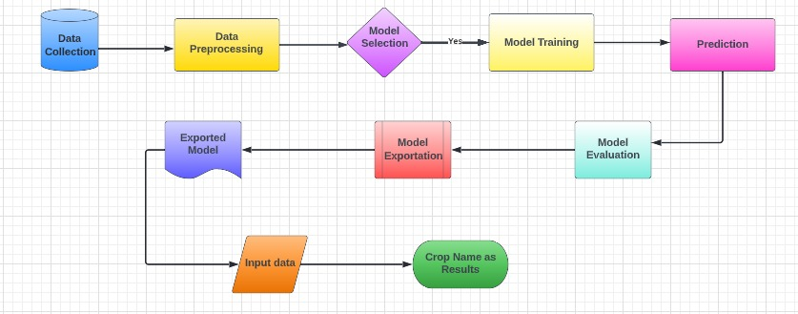

Fig.1 System architecture diagram

A system architecture is a conceptual model using which we can define the structure and behavior of that system. It is a formal representation of a system. Depending on the context, system architecture can be used to refer to either a model to describe the system or a method used to build the system. Building a proper system architecture helps in analysis of the project, especially in the early stages. Figure 1 depicts the system architecture and is explained in the following section.

1. RESULTS & PERFORMANCE ANALYSIS

For the purposes of this project we have used four popular algorithms:

Decision Trees, Logistic regression, Support Vector Machine and Random Forest. All the algorithms are based on supervised learning. Our overall system is divided into two modules:

• Crop recommender

• Fertilizer Recommender/Suggestion

Accuracy Comparison of ML Models:

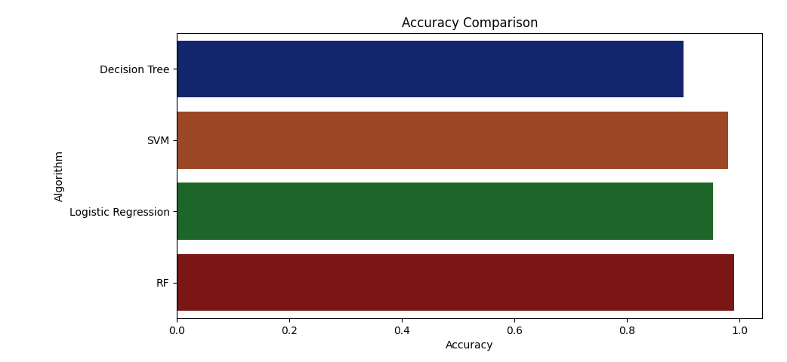

Fig.2 Accuracy comparison

|  |  |
| --- | --- |
| Algorithm | Accuracy (%) |
| Decision Tree | 90% |
| SVM | 97% |
| Logistic Regression | 95% |
| Random Forest | 99% |

Hence, Random Forest is our Final efficient model.

1. OUPUT FOR CROP RECOMMENDER

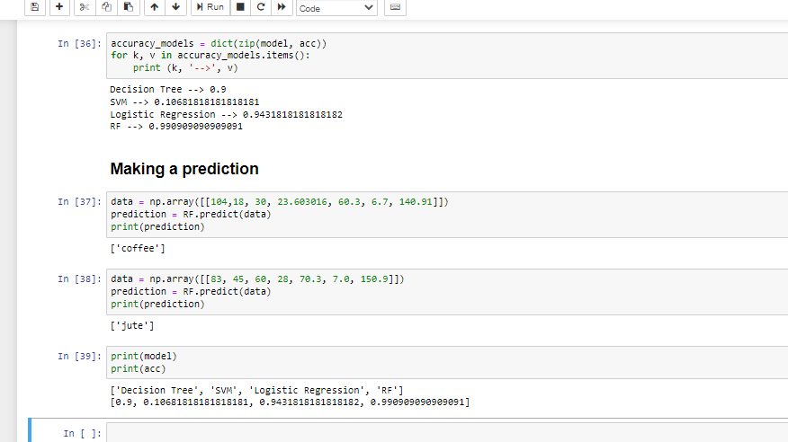

Fig.3 Output Crop Recommender

1. FERTILIZER RECOMMENDER/SUGGESTION

The fertilizer recommendation system is purely python logic based. In this we compare the data (optimum nutrients for growing the crop) with the user’s entered data. Then nutrient having maximum difference is made as HIGH or LOW and according to that suggestions will be fetched.

1. ADVANTAGES

[1] Improve farm management efficiency by adjusting field/crop treatments

[2] Ensure profitability, sustainability and protection of the environment

[3] To use new technologies to increase crop yields and profitability while lowering the levels of traditional Inputs needed to grow crops

[4] Optimize efforts and resources, reduce consumption and waste, and boost land productivity

[5] It will reduce excessive chemical usage in crop production

1. LIMITATIONS

[1] Extremely demanding work particularly collecting and then analyzing the data.

[2] Accuracy depends upon input dataset

[3] Most of the farmer not aware of such program like precision agriculture using machine learning farmer don’t know the technology

[4] Complexity grows with data.

1. CONCLUSION

All This system helps the farmer to choose the right crop by providing insights that ordinary farmers don't keep track of thereby decreasing the chances of crop failure and increasing productivity. It also prevents them from incurring losses. The system can be extended to the web and can be accessed by millions of farmers across the country. We could achieve an accuracy of 90 percent from the Decision Trees, an accuracy of 70.6 percent from the Support Vector Machine, an accuracy of 94.30 percent from the Logistic Regression and an accuracy of 99.09 percent from the Random Forest model. Further development is to integrate the crop recommendation system with another subsystem, yield predictor that would also provide the farmer an estimate of production if he plants the recommended crop.

VI. REFERENCES

[1] 2019, 10th International Conference on Computing, Communication and Networking Technologies, “Low-cost IOT+ML design for smart farming with multiple applications”, Fahad Kamraan Syed, Agniswar Paul, Ajay Kumar, Jaideep Cherukuri.

[2] 2019 IEEE “ Smart Management of Crop Cultivation using IoT and Machine Learning” Archana Gupta, Dharmil Nagda, Pratiksha Nikhare, Atharva Sandbhor

[3] Radhika, Narendiran, “Kind of Crops and Small Plants Prediction using IoT with Machine Learning,” International Journal of Computer & Mathematical Sciences, 2018.

[4] “Crop Recommendation on Analyzing Soil Using Machine Learning” Anguraj.Ka, Thiyaneswaran.Bb, Megashree.Gc, Preetha Shri.J.Gd, Navya.Se, Jayanthi. Jf, 2020.

[5] “Classification of Soil and Crop Suggestion using Machine Learning Techniques”, A. Mythili , IEEE 2019.

[6] Mehta, P., Shah, H., Kori, V., Vikani, V., Shukla, S., & Shenoy, M.,2018. “Survey of unsupervised machine learning algorithms on precision agricultural data”, IEEE

[7] “IOT based Crop Recommendation, Crop Disease Prediction and Its Solution” Rani Holambe, Pooja Patil, Padmaja Pawar, Saurabh Salunkhe , Mr. Hrushikesh Joshi, 2019 IRJET